Course Instructor

**Mam Shahela Saif**

Members:

Ayesha Shahid (22i-2483)

Saima Saleem (22i-2498)

Ali Kazmi (22i-2472)

Date:

5-12-2023

Fall 2023



**Department of Computer Science**

FAST – National University of Computer & Emerging Sciences

**Project intro:**

The project assigned to us was a game to be created along with all the principles from data structure in c plus plus language. We named the project as “**car game**”.

**Components:**

It consists of following major components:

* Menu
* Leader Board
* Manual mode
* Auto mode

**Menu:**

A user-friendly menu to provide a friendly game play to the players during the game.

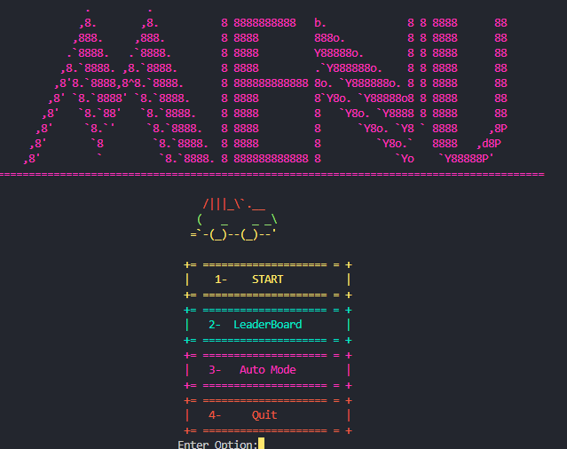

**Leader Board**

A leader board has been maintained using trees :

Leader board consist of its own node class

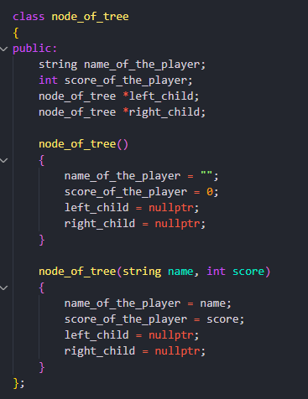

It consists of score and player name as we were instructed

The function to insert the details of the player in the tree it takes the tree as input and player name and score.

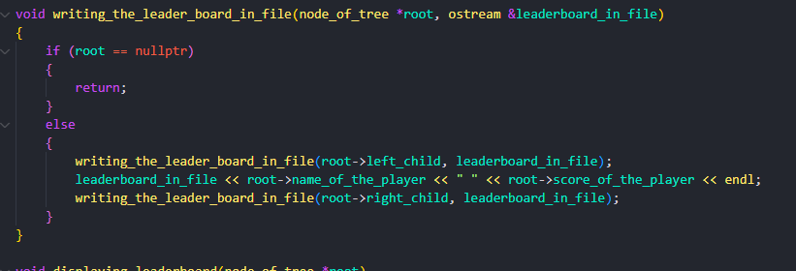

In order to save the details of the players for after run time purpose the details are stored in file via this function. This takes tree and file object as input .

To display the leaderboard above mentioned function is called.

**Manual:**

In the manual file following screen shots indicate the display of the home screen.

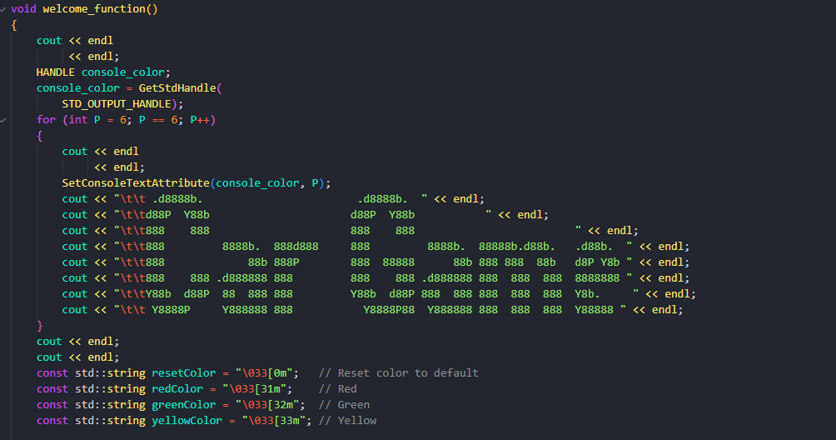

The welcome screen

**Node class:**

It consists of a value int to check a value a weight and linked list inside it to store all the connections

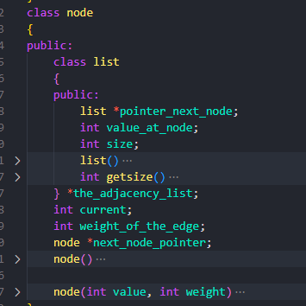

**Graph :**

In the graph class 10 cross 10 matrix maintains a maze and in which car moves from source to destination and obstacles are displayed .

Its function are explained below

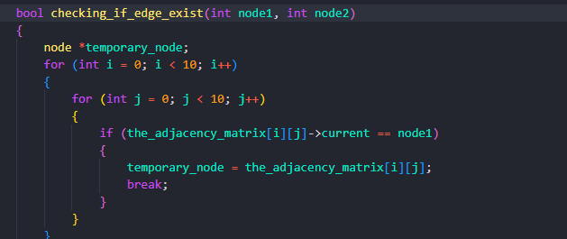 function to check if the connection exist between two nodes.

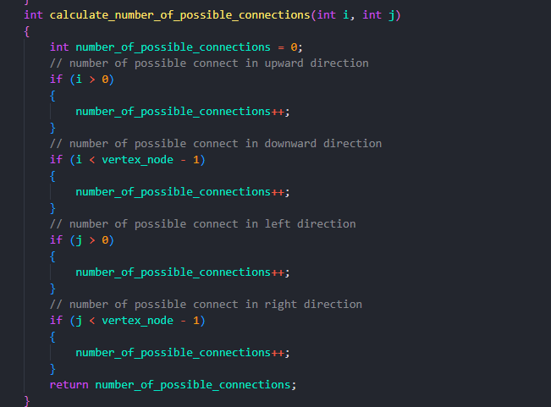

To calculate the number of possible connection a node can only be connected to 4 nodes maximum **top bottom left right** .this function ensures this .

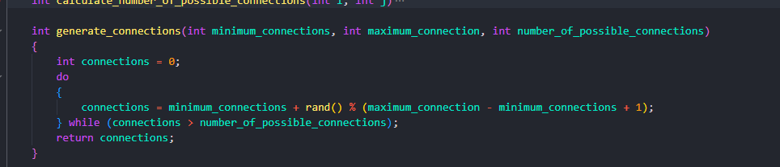 This function is responsible to calculate the number of connections for each node this takes number of minimum connections which can be one and maximum can be 4 .**no node can have zero connection.**



These two functions are responsible to make connections with other nodes randomly. I indicate number of rows and j indicates numbers of columns.

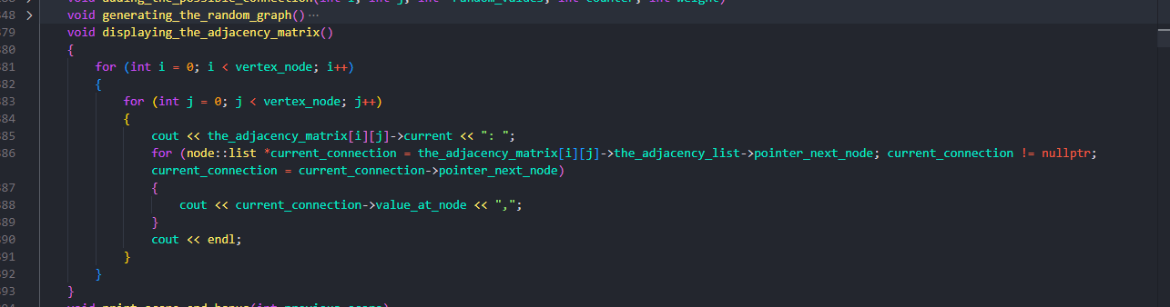 the function

 generating_the_random_graph

plays the key role in setting the graph the display function displays the values at each node.

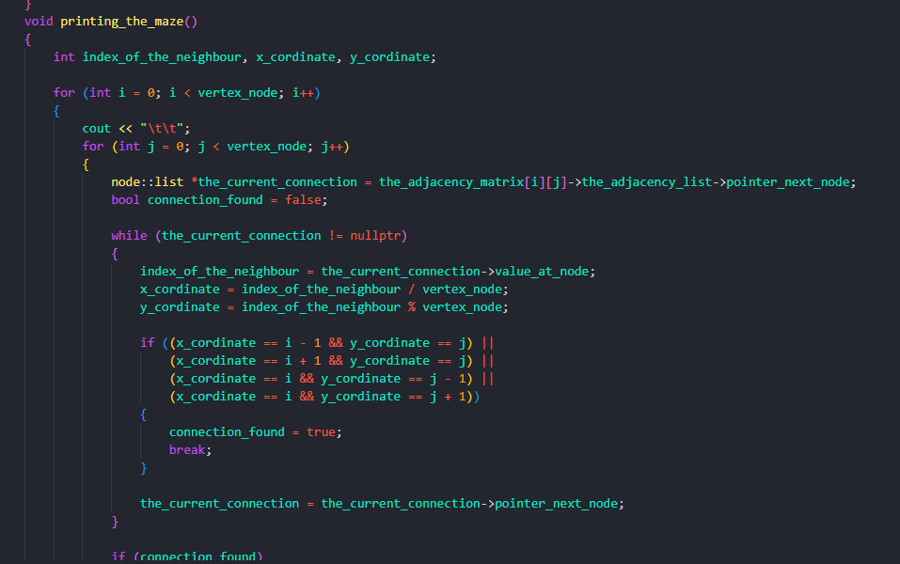 the function to display the maze the function has different colors included in it to make eye catching display .

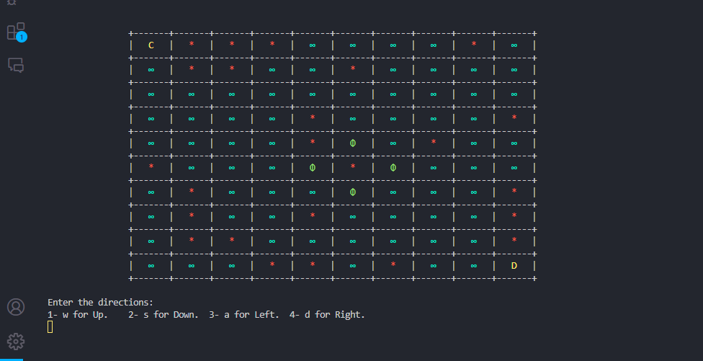

The screen looks some what like this

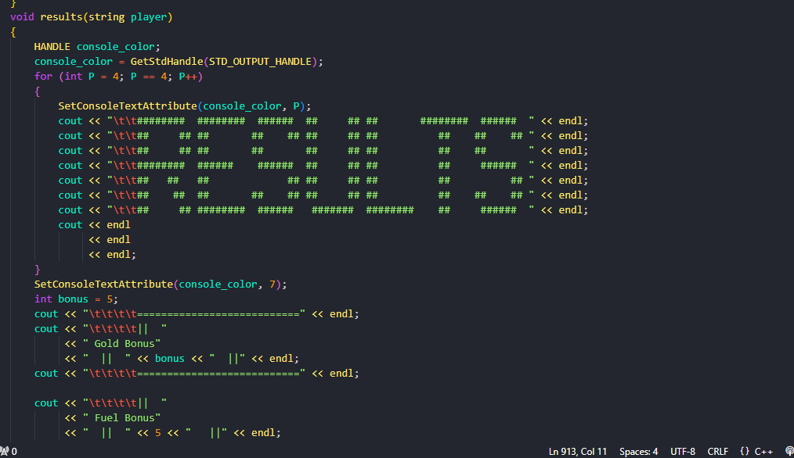 this function displays results and right the score into the file score included points bonuses and fuels bonuses.

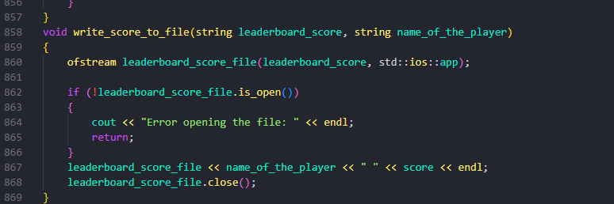 the function in manual to write the score into the file

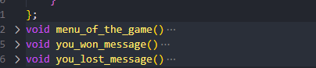

the function to display messages to encourage UI.

the function to show fly car.

the function to ensure car mechanics move up move down move left and move right which are integrated with keyboard.

**Auto mode:**

In auto mode Dijkstra algorithm is used to find the shortest path from a source node to a destination node.

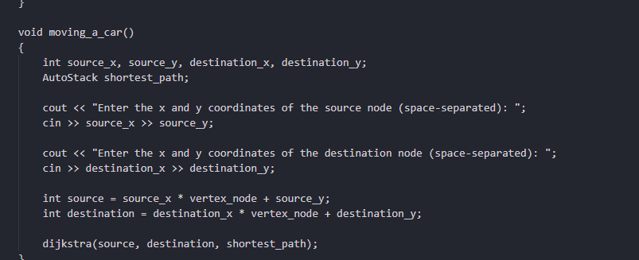 the function that takes inputs coordinates from the user and starts the game

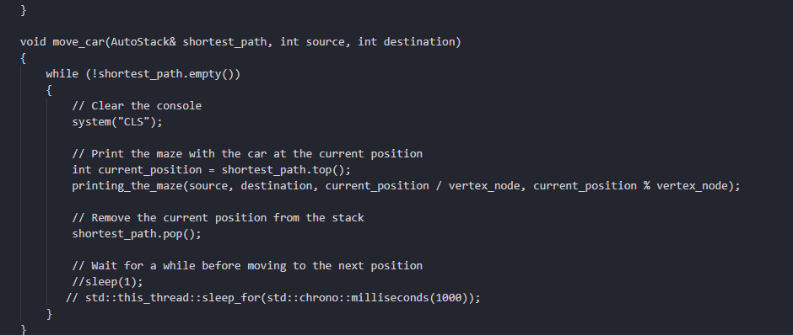the function that takes stack as input and while popping stack it moves the car this function uses cls function which clear screen to show dynamic movement of car

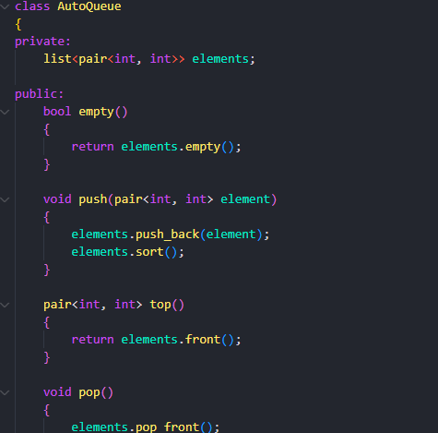

The priority queue for the function of dijskta

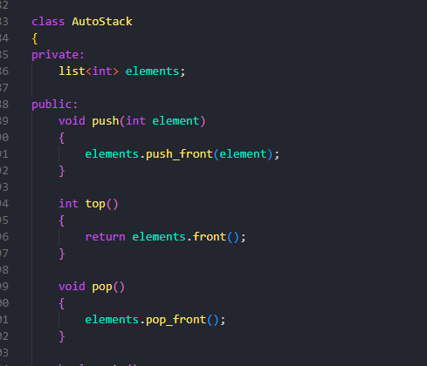

The stack to push the nodes

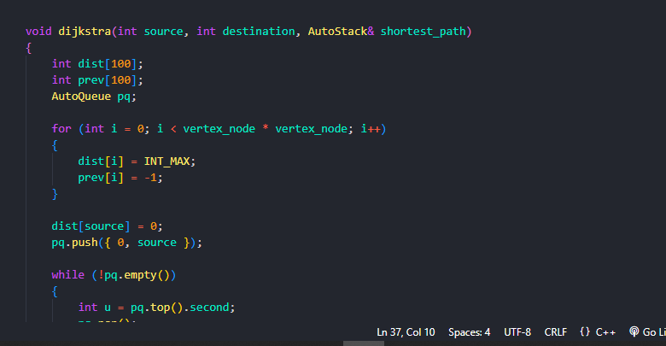 the main central function of the auto part it takes source and destination from the user finds the shortest path from the source to the destination .

**The end**